727721EUIT151

DAY_09

1

package day9;

import org.testng.annotations.Test;

import org.testng.Assert;

import org.testng.annotations.DataProvider;

public class Calculator {

*@Test*(dataProvider = "dp")

public void add(Integer n1, Integer n2) {

int actual=n1+n2;

int expected=30;

Assert.*assertEquals*(actual,expected);

System.***out***.println("ADDED");

}

*@Test*(dataProvider="dp")

public void sub(Integer n1,Integer n2) {

int actual1=n2-n1;

int expected1=10;

Assert.*assertEquals*(actual1,expected1);

System.***out***.println("SUBTRACTED");

}

*@Test*(dataProvider="dp")

public void mul(Integer n1,Integer n2) {

int actual2=n1*n2;

int expected2=200;

Assert.*assertEquals*(actual2,expected2);

System.***out***.println("MULTIPLIED");

}

*@Test*(dataProvider="dp")

public void div(Integer n1,Integer n2) {

int actual3=n2/n1;

int expected3=2;

Assert.*assertEquals*(actual3,expected3);

System.***out***.println("DIVIDED");

}

*@DataProvider*

public Object[][] dp() {

return new Object[][] {

new Object[] {10,20 },

};

}

}

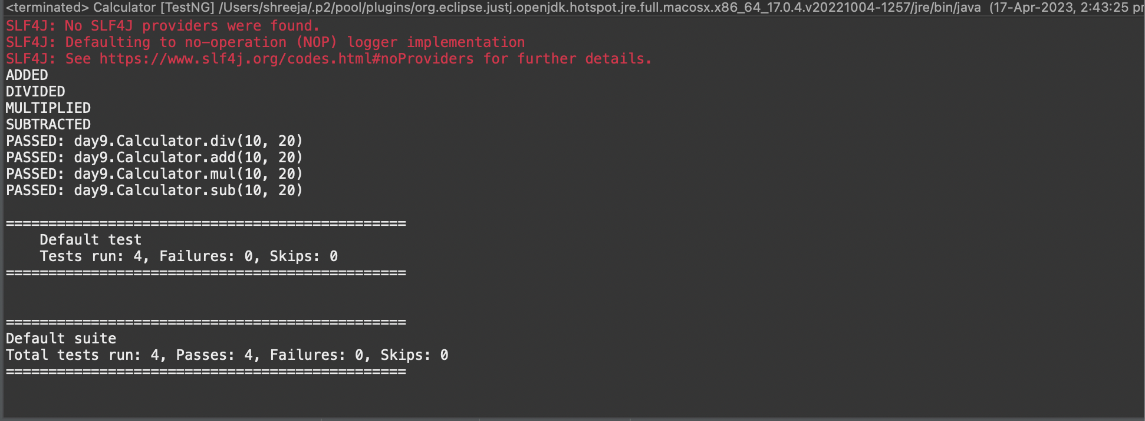

2

Task 1

package com.demo.test;

import java.util.concurrent.TimeUnit;

import org.openqa.selenium.By;

import org.openqa.selenium.WebDriver;

import org.openqa.selenium.chrome.ChromeDriver;

import org.openqa.selenium.chrome.ChromeOptions;

import org.testng.Assert;

import org.testng.annotations.BeforeMethod;

import org.testng.annotations.Test;

import io.github.bonigarcia.wdm.WebDriverManager;

public class task_7 {

WebDriver driver;

@Test

public void tc1() throws InterruptedException {

ChromeOptions co=new ChromeOptions();

co.addArguments("--remote-allow-origins=*");

WebDriverManager.chromedriver().setup();

driver=new ChromeDriver(co);

driver.get("https://www.godaddy.com/");

driver.manage().window().maximize();

Thread.sleep(3000);

String expectedTitle="Domain Names, Websites, Hosting & Online Marketing Tools - GoDaddy IN";

String actualTitle=driver.getTitle();

System.out.println(actualTitle);

Assert.assertEquals(expectedTitle,actualTitle);

String CurrentUrl=driver.getCurrentUrl();

String ExpectedUrl="https://www.godaddy.com/en-in";

Assert.assertEquals(CurrentUrl, ExpectedUrl);

}

@Test

public void tc2() throws InterruptedException{

ChromeOptions co=new ChromeOptions();

co.addArguments("--remote-allow-origins=*");

WebDriverManager.chromedriver().setup();

driver=new ChromeDriver(co);

driver.get("https://www.godaddy.com/");

driver.manage().window().maximize();

driver.manage().timeouts().implicitlyWait(10,TimeUnit.SECONDS);

driver.findElement(By.xpath("//*[@id=\"id-631b049a-e9c0-4d24-8710-c504745206dd\"]/div[2]/div[1]/ul/li[1]/button")).click();

driver.findElement(By.xpath("//*[@id=\"id-631b049a-e9c0-4d24-8710-c504745206dd\"]/div[2]/div[1]/ul/li[1]/div/div[2]/div[1]/ul/li[2]/a")).click();

}

@Test

public void testCase1() {

String expectedTitle="Domain Names, Websites, Hosting & Online Marketing Tools - GoDaddy IN";

String actualTitle=driver.getTitle();

System.out.println(actualTitle);

Assert.assertEquals(expectedTitle,actualTitle);

String CurrentUrl=driver.getCurrentUrl();

String ExpectedUrl="https://www.godaddy.com/en-in";

Assert.assertEquals(CurrentUrl, ExpectedUrl);

}

@Test

public void testCase2() {

driver.manage().timeouts().implicitlyWait(10,TimeUnit.SECONDS);

driver.findElement(By.xpath("/html/body/header/div/section/div/div[1]/nav/div[2]/div[1]/ul/li[1]/button")).click();

driver.findElement(By.xpath("/html/body/header/div/section/div/div[1]/nav/div[2]/div[1]/ul/li[1]/div/div[2]/div[1]/ul/li[2]/a")).click();

}

@BeforeMethod

public void beforeMethod() throws InterruptedException {

WebDriverManager.chromedriver().setup();

ChromeOptions co=new ChromeOptions();

co.addArguments("--remote-allow-origins=*");

driver=new ChromeDriver(co);

driver.get("https://www.godaddy.com/");

driver.manage().window().maximize();

Thread.sleep(3000);

}

}

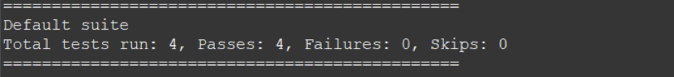

Task2

package com.demo.test;

import org.testng.annotations.Test;

import io.github.bonigarcia.wdm.WebDriverManager;

import org.testng.annotations.BeforeMethod;

import java.util.concurrent.TimeUnit;

import org.openqa.selenium.By;

import org.openqa.selenium.WebDriver;

import org.openqa.selenium.chrome.ChromeDriver;

import org.openqa.selenium.chrome.ChromeOptions;

import org.testng.Assert;

import org.testng.annotations.AfterMethod;

public class D_9_T_2 {

WebDriver driver;

@Test

public void check() throws InterruptedException {

Thread.sleep(5000);

String url = driver.getCurrentUrl();

String title = driver.getTitle();

String expectedUrl = "https://www.godaddy.com/en-in";

String expectedTitle = "Domain Names, Websites, Hosting & Online Marketing Tools - GoDaddy IN";

Assert.assertEquals(url,expectedUrl);

Assert.assertEquals(title,expectedTitle);

}

@BeforeMethod

public void BeforeMethod() {

ChromeOptions co = new ChromeOptions();

co.addArguments("--remote-allow-origins=*");

WebDriverManager.chromedriver().setup();

driver = new ChromeDriver(co);

driver.get("https://godaddy.com/en-in");

driver.manage().window().maximize();

}

@AfterMethod

public void AfterMethod() {

driver.close();

}

@Test

public void f2() throws InterruptedException{

ChromeOptions co=new ChromeOptions();

co.addArguments("--remote-allow-origins=*");

WebDriverManager.chromedriver().setup();

driver=new ChromeDriver(co);

driver.get("https://www.godaddy.com/");

driver.manage().window().maximize();

driver.manage().timeouts().implicitlyWait(10,TimeUnit.SECONDS);

driver.findElement(By.xpath("//*[@id=\"id-631b049a-e9c0-4d24-8710-c504745206dd\"]/div[2]/div[1]/ul/li[1]/button")).click();

driver.findElement(By.xpath("//*[@id=\"id-631b049a-e9c0-4d24-8710-c504745206dd\"]/div[2]/div[1]/ul/li[1]/div/div[2]/div[1]/ul/li[2]/a")).click();

}

@Test

public void f3() throws InterruptedException{

ChromeOptions co=new ChromeOptions();

co.addArguments("--remote-allow-origins=*");

WebDriverManager.chromedriver().setup();

driver=new ChromeDriver(co);

driver.get("https://www.godaddy.com/");

driver.manage().window().maximize();

Thread.sleep(5000);

String url = driver.getCurrentUrl();

String expectedUrl = "https://www.godaddy.com/en-in";

Assert.assertEquals(url,expectedUrl);

}

}

